Part Number BF30 / ORANGE RETRO-FIT CONNECTOR

BF30 - 30 Amp 125V ORANGE CONNNECTOR

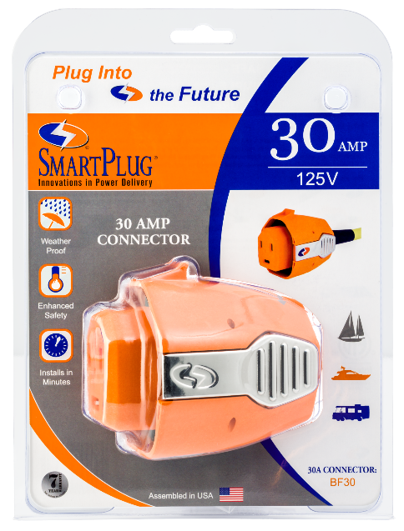
30 AMP 125V ORANGE RETRO-FIT CONNECTOR The 30A 125V inlet offers superior performance and ease of use.

- Eliminates Overheating - Increased pin & clip surface area greatly improves electrical conductivity during high amperage demand.

- Ease of Use - No twist required, the unique plug body shape and push-in design means it only goes in the right way every time - even in the dark!

- Multi-Point Locking System - Side clips lock the plug securely into the inlet which eliminates any stress on the pins from movement of the power cord.

- Weatherproof Seals - Multi-fin silicone gaskets installed in the inlet cover and interior of the plug body eliminates moisture penetration.

